### 1. See the below picture and create the exact table with exact formatting. Font – ‘Times New Roman’ Size – 14, Color of first line Orange.

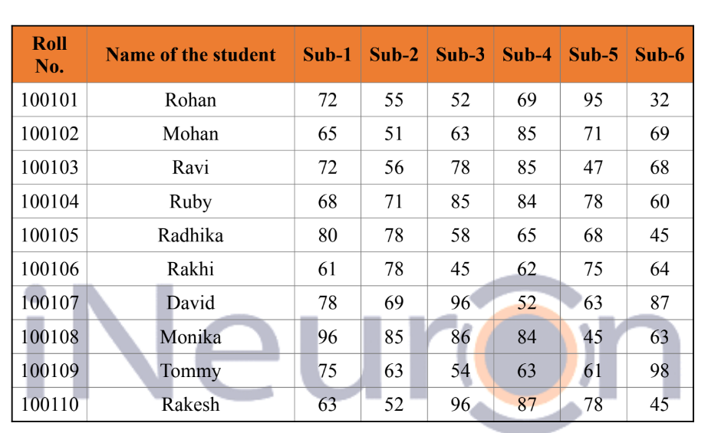

#### Ans:

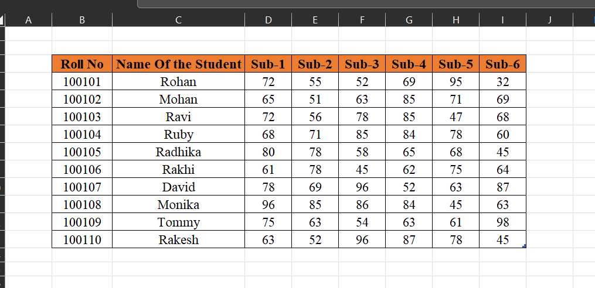

### 2. From the above table use Sum Formula and find the total for each student.

#### Ans:

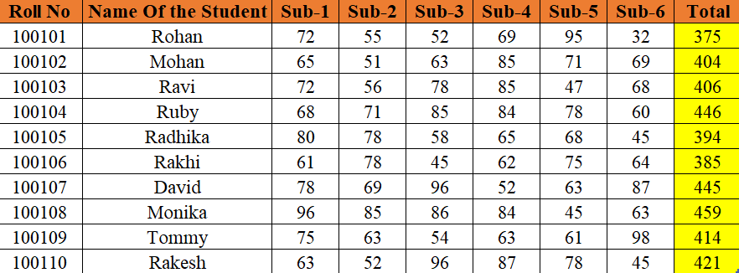

### 3. Calculate Average for each student in the next row. Use Formulas.

#### Ans:

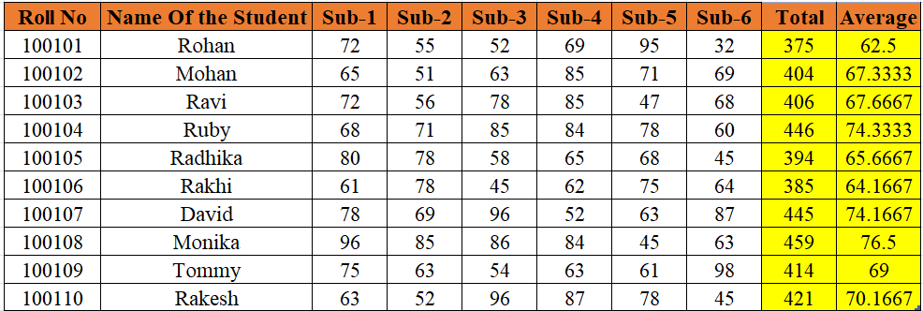

### 4. Calculate Rank for each student. Use Formulas.

#### Ans:

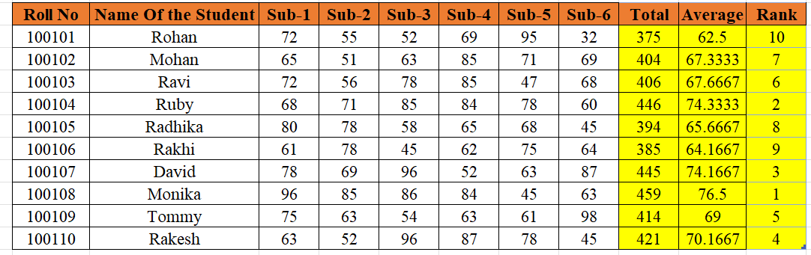

### 5. Calculate Percentage for each student. Use Formulas. Round off the decimals up to 2 points.

#### Ans:

